Exercise 1, 2 and 5 rory lange

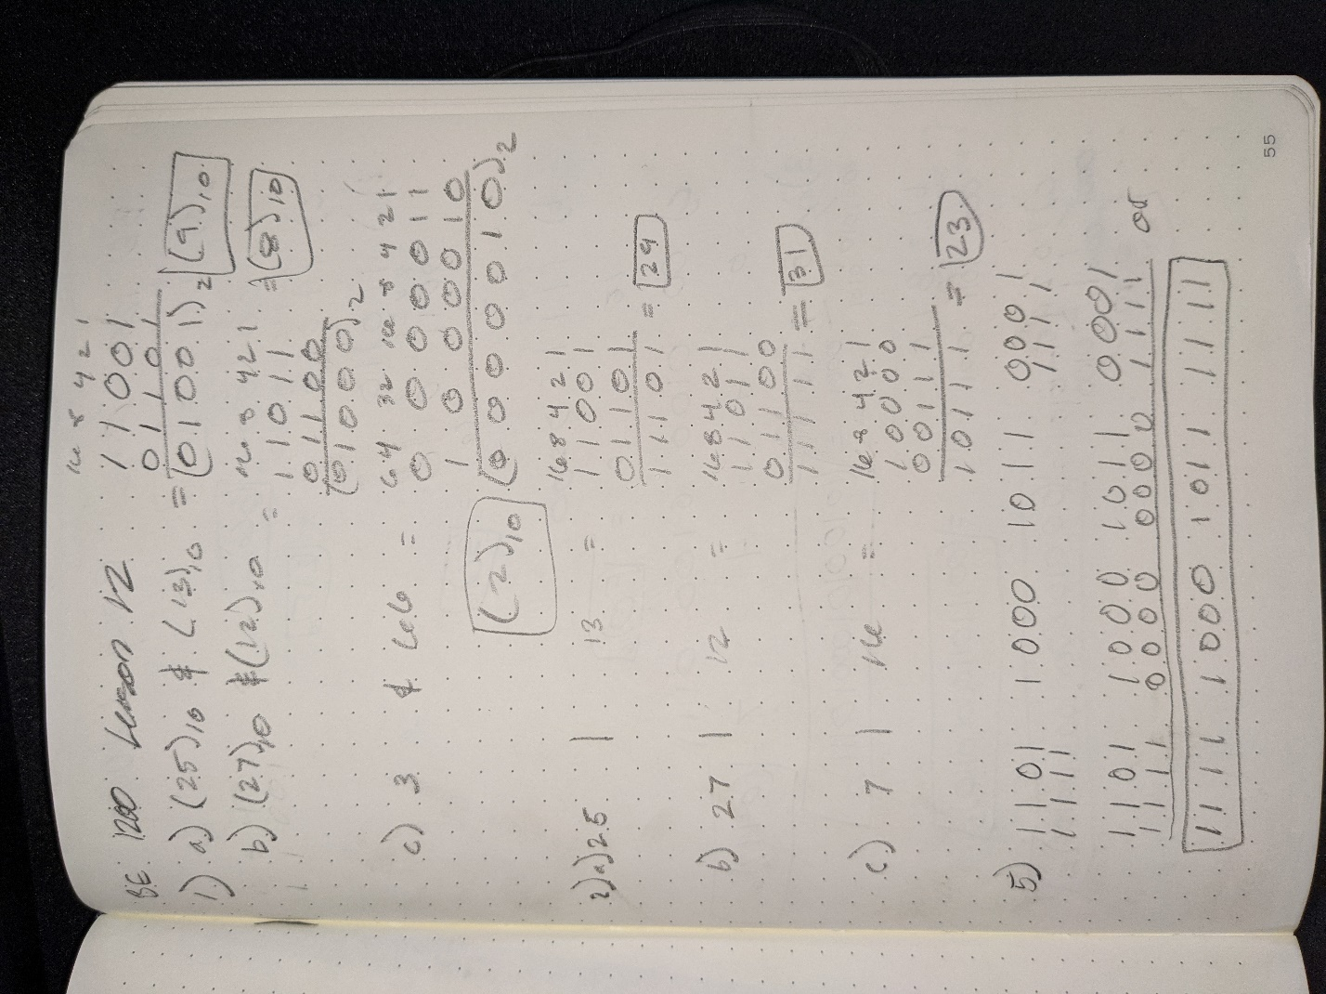

Exercise 3

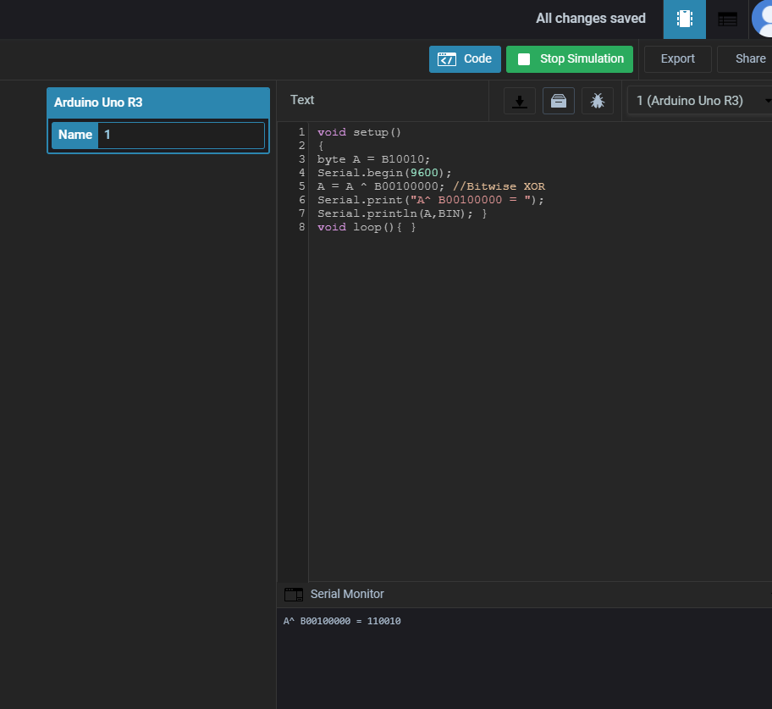

Exercise 4 code is bugged it says there is an error but there isn’t an error

